Supplementary Table Titles
Table S1 Elemental composition of soil with different degree of deterioration from Jinsha earthen site as determined by Scanning electron microscope - energy dispersive spectrometer (SEM-EDS).
Table S2 The proportions of ten most abundant bacterial phyla in soil with different degree of deterioration from Jinsha earthen site. S1, no obvious deterioration; S2, mild deterioration; S3, moderate deterioration; S4, severe deterioration.
Table S3 The proportions of ten most abundant bacterial genera in soil with different degree of deterioration from Jinsha earthen site. S1, no obvious deterioration; S2, mild deterioration; S3, moderate deterioration; S4, severe deterioration.
Table S4 The proportions of fungal phyla in soil with different degree of deterioration from Jinsha earthen site. S1, no obvious deterioration; S2, mild deterioration; S3, moderate deterioration; S4, severe deterioration.
Table S5 The proportions of thirty most abundant fungal genera in soil with different degree of deterioration from Jinsha earthen site. S1, no obvious deterioration; S2, mild deterioration; S3, moderate deterioration; S4, severe deterioration.
Table S6 The mineral and chemical components in Jinsha earthen site, Chengdu, China. Data from Li (2007).
Supplementary Figure Legends
Figure S1 The examples of excavated relics (a) and panorama of Jinsha Site Museum (b).
Figure S2 The rarefaction curves of bacterial (a) and fungal (b) operational taxonomic units (OTUs).
Figure S3 Differentially abundant bacterial (a) and fungal (b) taxa in soil with different degree of deterioration from Jinsha earthen site. S1, no obvious deterioration; S2, mild deterioration; S3, moderate deterioration; S4, severe deterioration.

Table S1
Sample | Elements (w/%)
Sample | C | O | Na | Mg | Al | Si | S | K | Ti | Fe
S1 | 10.43±1.13^{c} | 32.15±1.36^{b} | 0.34±0.06ª | 0.86±0.10^{c} | 19.51±0.76ª | 24.27±0.32ª | - | 10.40±0.30ª | - | 1.21±0.21^{bc}
S2 | 12.46±0.84^{b} | 33.67±0.93^{b} | 0.55±0.09ª | 1.00±0.04^{c} | 18.33±0.78^{b} | 23.29±0.27ª | - | 8.39±0.30^{b} | 0.34±0.10ª | 1.98±0.36^{b}
S3 | 16.63±0.91ª | 44.61±0.71ª | 0.41±0.41ª | 8.49±0.36^{b} | 8.02±0.06^{c} | 9.57±0.83^{b} | 1.90±0.23^{b} | 0.01±0.01^{d} | - | 10.35±0.8ª
S4 | 16.81±0.72ª | 46.31±1.37ª | - | 13.86±0.78ª | 1.80±0.43^{d} | 2.11±1.34^{c} | 18.04±0.51ª | 0.55±0.08^{c} | - | 0.52±0.14^{c}
The results are average ± standard deviation (n=3). Different superscript letters in a column indicate statistical significant difference (p < 0.05) in the least significant difference test. S1, no obvious deterioration; S2, mild deterioration; S3, moderate deterioration; S4, severe deterioration; –, not detected.

Table S2
Taxonomy | Relative Abundance
Taxonomy | S1 | S2 | S3 | S4
Actinobacteria | 76.67%±2.54%ª | 82.18%±10.7%ª | 20.99%±9.78%^{b} | 18.03%±16.54%^{b}
Bacteroidetes | 0.93%±0.38%ª | 2.57%±1.99%ª | 16.02%±15.89%ª | 27.17%±23.09%ª
Proteobacteria | 8.83%±0.32%^{b} | 7.50%±3.57%^{b} | 33.91%±5.63%ª | 25.84%±7.86%ª
Firmicutes | 8.13%±0.87%^{b} | 5.55%±3.84%^{b} | 18.18%±4.92%ª | 23.63%±5.03%ª
Cyanobacteria | 4.09%±1.09%ª | 0.41%±0.21%^{b} | 3.58%±1.87%ª | 0.86%±1.19%^{b}
Fusobacteria | 0.04%±0.02%ª | 0.39%±0.33%ª | 0.97%±0.09%ª | 0.95%±0.70%ª
Acidobacteria | 0.15%±0.07%ª | 0.09%±0.09%ª | 0.47%±0.15%ª | 0.61%±0.57%ª
Deinococcus-Thermus | 0.46%±%0.13^{ab} | 0.75%±0.32%ª | 0.33%±0.24%^{ab} | 0.10%±0.14%^{b}
Chloroflexi | 0.10%±0.05%ª | 0.07%±0.05%ª | 0.39%±0.23%ª | 0.38%±0.43%ª
Gemmatimonadetes | 0.02%±0.03%ª | 0.04%±0.03%ª | 0.07%±0.06%ª | 0.22%±0.22%ª
Others | 0.58%±0.08%ª | 0.44%±0.37%ª | 5.09%±7.78%ª | 2.21%±2.24%ª
The results are average ± standard deviation (n=3). Different superscript letters in a column indicate statistical significant difference (p < 0.05) in the least significant difference test. S1, no obvious deterioration; S2, mild deterioration; S3, moderate deterioration; S4, severe deterioration; –, not detected.

Table S3
Taxonomy | Relative Abundance
Taxonomy | S1 | S2 | S3 | S4
Rubrobacter | 73.62%±2.74%ª | 74.43%±11.67%ª | 14.03%±6.22%^{b} | 0.75%±0.36%^{b}
Bacteroides | 0.15%±0.06%ª | 0.77%±0.68%ª | 10.33%±14.73%ª | 19.13%±23.05%ª
Corynebacterium_1 | 0.18%±0.06%ª | 0.13%±0.07%ª | 0.48%±0.38%ª | 7.9%±1.27%ª
Ralstonia | 0.25%±0.07%ª | 1.86%±0.17%ª | 7.31%±4.01%ª | 5.03%±4.68%ª
Faecalibacterium | 0.32%±0.31%ª | 1.05%±0.91%ª | 2.86%±2.62%ª | 4.56%±2.61%ª
Acinetobacter | 0.28%±0.12%ª | 0.26%±0.22%ª | 3.26%±2.44%ª | 0.89%±0.59%ª
Escherichia-Shigella | 0.02%±0.02%ª | 0.34%±0.23%ª | 1.23%±1.46%ª | 2.67%±2.75%ª
Propionibacterium | 0.38%±0.15%ª | 0.45%±0.25%ª | 1.43%±0.79%ª | 2.23%±2.89%ª
Shewanella | 0.21%±0.14%^{b} | 0.70%±0.62%^{b} | 2.82%±0.73%ª | 2.17%±0.28%ª
Halomonas | 0.30%±0.07%^{b} | 0.77%±0.65%^{b} | 2.49%±0.73%ª | 1.37%±0.69%^{ab}
Others | 24.54%±2.32%ª | 19.45%±8.63%ª | 55.83%±13.21%ª | 52.46%±19.01%ª
The results are average ± standard deviation (n=3). Different superscript letters in a column indicate statistical significant difference (p < 0.05) in the least significant difference test. S1, no obvious deterioration; S2, mild deterioration; S3, moderate deterioration; S4, severe deterioration; –, not detected.

Table S4
Taxonomy | Relative Abundance
Taxonomy | S1 | S2 | S3 | S4
Ascomycota | 97.24%±0.57%ª | 98.78%±1.30%ª | 97.35%±0.07%ª | 95.95%±2.7%ª
Basidiomycota | 2.75%±0.06%ª | 1.12%±1.11%ª | 2.42%±0.006%ª | 2.63%±1.68%ª
Zygomycota | <0.01% | 0.05%±0.08%ª | 0.12%±0.08%ª | 0.46%±0.63%ª
Glomeromycota | - | - | - | 0.02%±0.03%ª
Chytridiomycota | - | - | - | 0.01%±0.01%ª
Others | 0.01%±0.005%^{b} | 0.05%±0.09%^{b} | 0.11%±0.011%^{b} | 0.93%±0.81%ª
The results are average ± standard deviation (n=3). Different superscript letters in a column indicate statistical significant difference (p < 0.05) in the least significant difference test. S1, no obvious deterioration; S2, mild deterioration; S3, moderate deterioration; S4, severe deterioration; –, not detected.

Table S5
Taxonomy | Relative Abundance
Taxonomy | S1 | S2 | S3 | S4
Candida | 0.01%±0.00%ª | 0.12%±0.12%ª | 0.79%±0.35%ª | 32.74%±35.69%ª
Fusarium | 0.38%±0.36%^{b} | 50.56%±18.72%ª | 0.52%±0.19%^{b} | 0.93%±1.21%^{b}
Toxicocladosporium | 9.85%±1.02%^{b} | 3.31%±1.06%^{c} | 19.56%±3.06%ª | 0.4%±0.04%^{c}
Cladosporium | 14.78%±0.86%ª | 4.30%±2.90%^{c} | 11.76%±2.75%^{ab} | 8.45%±4.81%^{bc}
Alternaria | 10.78%±1.80%ª | 3.13%±0.61%^{b} | 8.17%±1.02%ª | 3.05%±3.10%^{b}
Periconia | 3.17%±0.54%ª | 0.12%±0.06%^{c} | 2.33%±0.43%^{b} | 0.23%±0.18%^{c}
Khuskia | 0.85%±0.15%^{c} | 1.9%±0.62%^{b} | 3.4%±0.25%ª | 0.05%±0.06%^{d}
Pseudopithomyces | 3.18%±0.42%ª | 0.38%±0.18%^{c} | 1.85%±0.40%^{b} | 0.05%±0.06%^{c}
Phaeosphaeria | 1.71%±0.36%ª | 0.55%±0.39%^{b} | 2.45%±0.84%ª | 0.16%±0.10%^{b}
Aspergillus | 1.3%±0.15%ª | 1.05%±0.29%ª | 1.18%±0.28%ª | 1.42%±1.27%ª
Pseudogymnoascus | - | 0.05%±0.09%ª | - | 0.97%±1.38%ª
Aureobasidium | 2.21%±0.19%ª | 1.65%±0.56%^{ab} | 2.22%±0.30%ª | 1.05%±0.71%^{b}
Waitea | 1.8%±0.47%ª | 0.59%±0.48%^{b} | 1.52%±0.60%ª | 0.01%±0.01%^{b}
Hyphodontia | 0.02%±0.02%ª | 0.02%±0.03%ª | 0.01%±0.01%ª | 0.69%±1.20%ª
Phoma | - | - | 0.02%±0.04%ª | 0.66%±1.13%ª
Stemphylium | 1.58%±0.27%ª | 1.31%±0.59%ª | 1.66%±0.23%ª | 0.02%±0.02%^{b}
Cryptococcus | 0.06%±0.01%^{b} | 0.05%±0.05%^{b} | 0.03%±0.03%^{b} | 0.86%±0.82%ª
Devriesia | 0.09%±0.02%ª | 1.03%±0.31%ª | 0.05%±0.01%ª | 0.6%±1.03%ª
Penicillium | 0.23%±0.13%ª | 0.20%±0.23%ª | 0.21%±0.12%ª | 0.69%±0.63%ª
Pseudeurotium | - | - | - | 0.44%±0.76%ª
Ophiosphaerella | 0.63%±0.21%ª | 0.46%±0.32%ª | 0.64%±0.06%ª | 0.44%±0.76%ª
Eudarluca | 0.83%±0.41%ª | 0.01%±0.00%^{b} | 0.03%±0.03%^{b} | -
Hongkongmyces | - | - | - | 0.42%±0.73%ª
Chaetomium | 0.10%±0.03%ª | 0.10%±0.12%ª | 0.19%±0.10%ª | 0.41%±0.70%ª
Humicola | - | - | - | 0.39%±0.67%ª
Mucor | - | - | - | 0.36%±0.62%ª
Botrytis | 0.41%±0.08%ª | 0.16%±0.23%ª | 0.24%±0.07%ª | 0.54%±0.44%ª
Monographella | 0.08%±0.02%ª | 0.18%±0.30%ª | 0.09%±0.08%ª | 0.33%±0.56%ª
Leptospora | 0.58%±0.17%ª | 0.24%±0.41%ª | 0.43%±0.42%ª | 0.01%±0.01%ª
Aphanoascus | - | - | - | 0.24%±0.42%ª
Others | 45.38%±1.62%ª | 28.54%±16.68%ª | 40.64%±25.67%ª | 43.37%±14.78%ª
The results are average ± standard deviation (n=3). Different superscript letters in a column indicate statistical significant difference (p < 0.05) in the least significant difference test. S1, no obvious deterioration; S2, mild deterioration; S3, moderate deterioration; S4, severe deterioration; –, not detected.
Table S6
Mineral component | Quartz | 20%-65%
 | Feldspar | 9%-18%
 | Illite ilerite | 7%-30%
 | Montmorillonite | 2%-12%
 | Chlorite | 5%-18%
 | Clay minerals | 14%-60%
Chemical component | SiO₂, Al₂O₃ | 60%-75%
 | Fe₂O₃, K₂O, MgO, CaO | 10%-15%
 | Na₂O, TiO₂, P₂O₅, MnO | 1%-2%

Figure S1
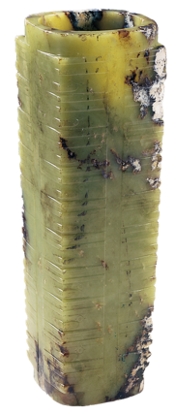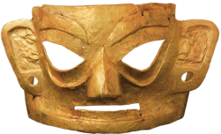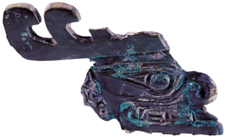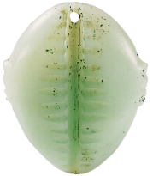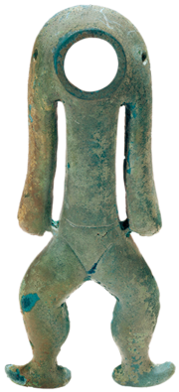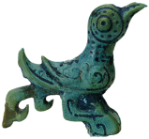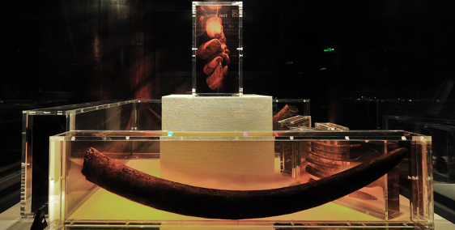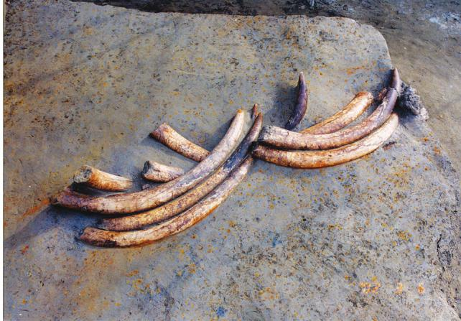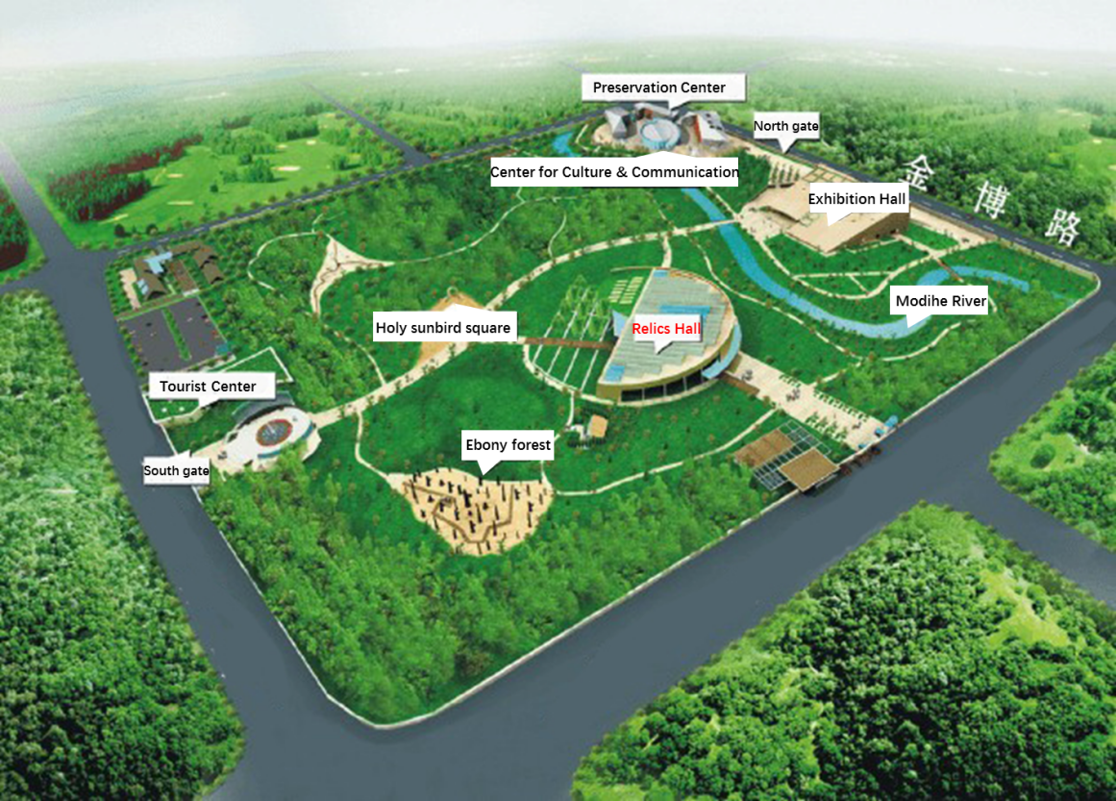
a
b
1
2
3
4
5
7
6
8
9
10
Note: 1: Jade Cong; 2: Jade shell; 3: Jade god; 4: Gold Band with Sun and Magic Bird; 5: Gold mask; 6: Bronze; 7: Bronze; 8: Bronze humanoid; 9, 10: ivory

Figure S2
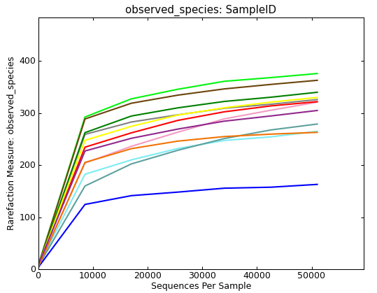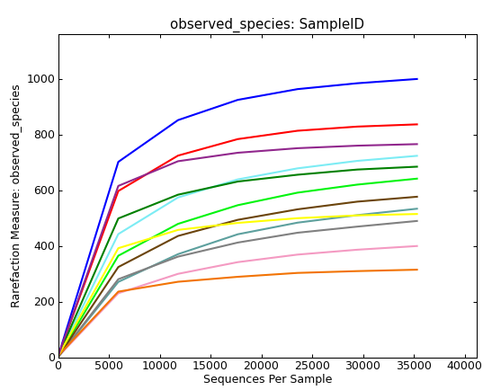
a
b

Figure S3
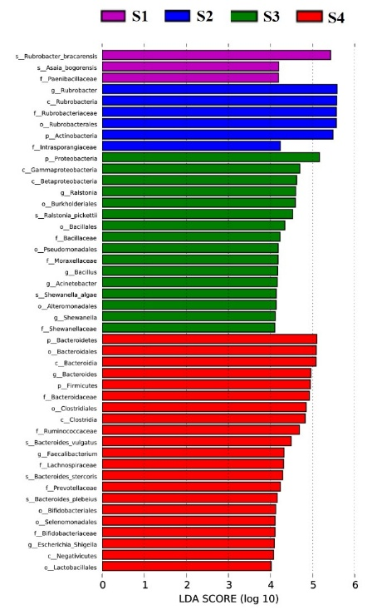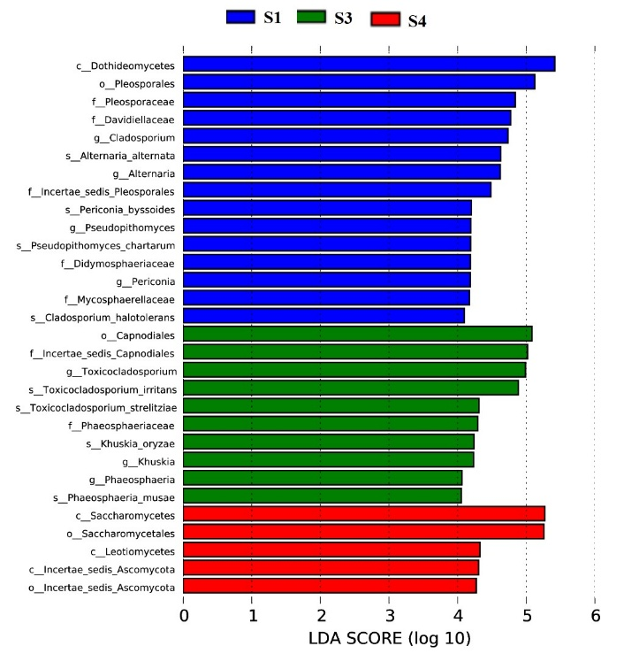
b
a

